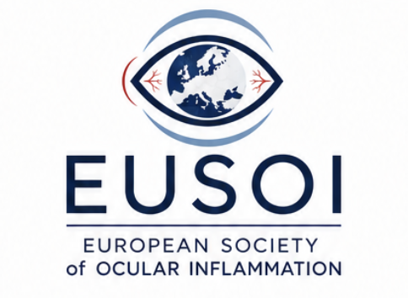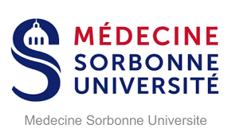

Inaugural Scientific Meeting of the European Society of Ocular Inflammation (EUSOI)

Therapy in Ocular Inflammation – The European Approach
Paris 4–5 September 2026
Novotel Paris Centre Tour Eiffel
61 Quai de Grenelle, 75015, Paris

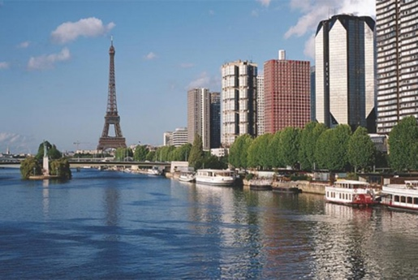

Registration free but mandatory: eusoi.org

Friday 4 September 2026

11:30 – 12:30
Registration

Foundations and Current Practice

12:30 – 12:45

Welcome and Opening Remarks
Carlos Pavesio President, EUSOI
Objectives of the Society
Vision for European Collaboration in Ocular Inflammation

12:45 – 13:45

Session 1: Systemic Therapy in Uveitis – The European Perspective Joke de Boer (The Netherlands) and Gilles Kaplanski (Marseille)
Benefits and risks of corticosteroids in uveitis Natasa Vidovic (Slovenia)
Efficacy of DMARDs in uveitis Mirjam van Velthoven (The Netherlands)
Treatment of uveitis in the era of biologicals, perspective of the new generation ophthalmologists Charlotte van Meerwijk (The Netherlands)

Early or late start with start biologicals? Perpective of a senior ophthalmologist.
Marc de Smet (Switzerland)
Discussion

13:50 – 14:50

Session 2: Local Therapies in Uveitis Carlos Pavesio (UK), Ahmed Abu El Asrar (Saudi Arabia)
(10-min keynote + 3 cases + discussion)
Keynote – Piergiorgio Neri (UAE)
Case 1- Management of UME – Alessandro Invernizzi (Italy)
Case 2- Management of PIC/MFC – Ilaria Testi (UK)
Case 3- Management of Retinal Vasculitis – Elisabetta Miserocchi (Italy)
Discussion

14:55-15:15

Industry Symposium – Agephapharma

Ultracortenol (prednisolone pivalate 5 mg/g) and its role in the management of ocular inflammation Yosuf El Shabrawy (Austria)

15:20 – 16:20
Coffee Break

16:25 – 17:25

Session 3: Complex Decision-Making in Uveitis Sofia Androudi (Greece) and Jarmila Heissigerova (Czech Republic)
(10-min keynote + 3 cases + discussion)
Keynote – Diagnostic strategies in complex uveitis Sara Touhami (France)

Case 1 – Masquerade syndrome Zohar Habot-Wilner (Israel)

Case 2 – Autoimmune uveitis Ioannis Papasavas (Switzerland)

Case 3 – Infectious uveitis Aniruddha Agarwal (UAE)
Discussion : Siham Chariba (Marocco), Cherif Titah (France), François Willermain (Belgium)

17:30-18:30

Industry Symposium – Founding Sponsor Symposium, Roche
18:30 Welcome reception

Saturday 5 September 2026

Advanced Therapies, Imaging and the Future

08:30 – 09:30

Session 4: Biologic Therapy in Uveitis Bahram Bodaghi (France) and David Saadoun (France)
(10-min keynote + 3 cases + discussion)

Keynote : Biotherapies in Uveitis : update and perspectives D. Saadoun (France)

Case 1 : Ines Leal (Portugal)

Case 2 : Anne-Claire Desbois (France)

Case 3 : William Tucker (UK)

Discussion : Marie-Josée Aubin (Canada), Mathilde Leclercq (France), Yosuf El Shabrawy (Austria)

09:35 – 10:35

Session 5: Imaging in Ocular Inflammation Elisabetta Miserocchi (Italy) + Bahram Bodaghi (France)
Multimodal imaging in posterior uveitis Luca De Simone (Italy)
OCT biomarkers of inflammatory activity Prithvi Ramthoul (France)
Widefield angiography and retinal vasculitis Ester Carreno (Spain)
Choroidal imaging (EDI-OCT, ICGA) Maria Vittoria Cicinelli (Italy)
Imaging endpoints in clinical trials Alessandro Marchese (Italy)

Discussion Marie-Hélène Errera (USA)

10:35 – 10:55
Coffee Break

10:55 – 11:55

Session 6: Orbital Inflammation optic neuritis and Scleritis Carlos Pavesio (UK) Valérie Touitou (France)
- Thyroid eye disease Jimmy Uddin (UK)
- IgG4-related orbital disease Federico Maestri (France)
- Necrotising and non-necrotising scleritis Julie Gueudry (France)
- Noninfectious optic neuritis Valerie Touitou (France)
- Multidisciplinary management (ophthalmology + rheumatology)
Panel discussion : Isabelle Hardy (Canada), Sebastien Abad (France)

11:55 – 12:55

Session 7: Ocular Surface Inflammation and Dry Eye. Christophe Baudouin, (President of the European Dry Eye Society) Dry eye in autoimmune disease
- Inflammation as a central mechanism of dry eye, Christophe Baudouin (France)
- Digital screen use in children : challenges for myopia progression and ocular surface, Dominique Bremond-Gignac (France)
- Biomarkers in ocular surface inflammation : challenges and usefulness, Marlies Gijs (The Netherlands)
- The role of microbiota in dry eye disease, Marc Labetoulle (France)
Discussion

13:00 – 14:00 Lunch

14:00 – 15:00

Industry Symposium - Founding Sponsor Symposium, Alimera
Long-Acting Intravitreal Therapy in Non-Infectious Uveitis
Optimising Outcomes with Iluvien

15:00 – 16:00

Session 8: Emerging Therapies and the Pipeline Alex Fonollosa (Spain) + David Saadoun (France)
Multidisciplinary session with internists and rheumatologists
- Introduction: Precision Immune Modulation in Uveitis Colin Chu (UK)
- Targeting ERAP to treat uveitis in the MHC-I-opathies. Jonas Kuiper (Netherlands)
- Brepocitinib – TYK2/JAK1 inhibition Elena Bolletta (Italy)
- Bimekizumab – Dual IL-17A/F inhibition Carmen Secada (Spain)
- Port-Delivery Platform (PDP): Sustained Intraocular Drug Delivery Aude Couturier (France)
Panel Discussion: Luca Cimino (Italy), Abdulrahman Albloushi (Saudi Arabia)

16:05 – 17:05

Session 9: European Research Priorities and Collaborative Strategy Pre-Prepared Strategic Working Session Talin Barisani (Austria), Marc De Smet (Switzerland)
Pre-Meeting Work:
- European-wide survey
- Priority theme identification
- Rapporteur concept briefs
- Draft proposals circulated in advance
Session Structure:
- Summary of survey findings
- Focused topic presentations
- Structured breakout discussions
- Consensus vote and action plan
Deliverable: Defined EUSOI Research Roadmap 2026–2028

17:10 – 18:00

Session 10: EUSOI Society Session (45 Minutes) Executive Board
- Summary of strategic outcomes
- Governance and committee structure
- Education and fellowship initiatives
- Strategic roadmap 2026–2028
- Member engagement and future meetings

18:00

Closing Remarks

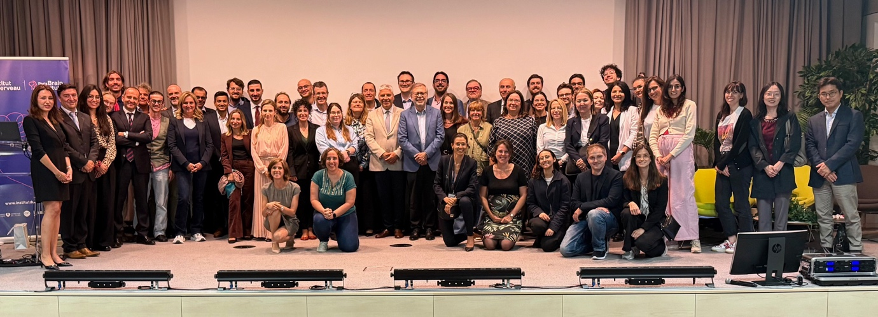

Paris, September 2025

